TWO MILE BROOK, BURNHAM, BUCKS.

There are two tributaries of the Thames in the western half of Slough, and these notes concern the more western of these two rivers, the one which flows from Burnham Beeches past Britwell and Cippenham into the Thames near Eton. On its way it passes by four protected nature reserves - Burnham Beeches, Cocksherd Wood, Lynch Hill Valley and Haymill Valley. These notes are by no means authoritative but do record what local people have always believed and experienced. Undoubtedly the Environment Agency has much greater technical knowledge. This river is historically recorded with the name Two Mile Brook.When the parish boundaries were devised in medieval times each parish in this locality had access to the Thames as well as access to high ground and to the major length of a tributary river. It appears that Burnham Parish's tributary river was Two Mile Brook.

The notes below are referenced to the location letters marked on the first of the attached maps.

A - The Project Sponge map shows the river rising north of Burnham Beeches. It is presumably a Chiltern chalk 'misbourne'.

B - It then surfaces in two lakes within Burnham Beeches. Burnham Beeches is owned and managed by the Corporation of the City of London.

C- It is next apparent at Swilley Pond, just south of Burnham Beeches. Until about 1980 Swilley Pond was usually full of water but since then it is more usually dry, only filling during exceptionally wet weather.

D - The water then continues flowing through the chalk, as well as down Walton Lane, to Cocksherd Wood. Cocksherd Wood is a statutory nature reserve and is owned by Slough Borough Council and managed informally by Evergreen 2000 Trust. This area is subject to fairly regular minor road flooding and in 2001 and in 2024 the wood itself was subjected to partial flooding which closed one of the footpaths. I believe that, after the 2001 flood, improvements were made to the drainage.

E - Lynch Hill Valley and Lammas Meadow are owned by Slough Council and managed informally by Evergreen 2000 Trust. The river is here confined to an underground culvert which carries the water below Lynch Hill Valley and Lammas Meadow. Occasionally a small area of Lynch Hill Valley near Long Furlong Drive floods and becomes an unlikely host to ducks.

F - The culvert now opens into Haymill Valley. Haymill Valley is a statutory nature reserve owned by Slough Counclil and leased to Berks, Bucks and Oxon Wildlife Trust. It has an nationally important reed bed habitat.

G - Next there is some land owned by the Environment Agency where there is a modern flood control system. Nearby is a small dam, built by volunteers, intended to keep Haymill Valley partially flooded. Nearby also is the site of Ay (or Ash) Mill which in Victorian times operated a water mill using Two Mile Brook's water flow.

H- The water is now again passed into an underground culvert as it passes under the Network Rail tracks and emerges in Cippenham Village as a series of open, narrow road-side streams.

Finally the water drains into the Thames somewhere near Eton.

Additional observations :

J - Surface water from Slough Trading Estate is passed through a modern control installation to drain into the Two Mile Brook at Haymill.

K - I believe that traditionally Two Mile Brook was held to have its source at Cant's Hill near the present Burnham Beeches Hotel (Grove House), Burnham Beeches at that time being disregarded as a source.

L - Water tends to diverge towards point L on Farnham Lane, near the eastern extent of Cocksherd Wood, where it regularly causes serious road flooding which the authorities seem unable to cure.

M - The houses in Dove House Crescent and Lynch Hill Lane, as well as a Pocket Park, have surface water drainage which I suspect drains into Two Mile Brook.

In the following maps I recognise the copyright of Project Sponge, the Environment Agency and the Ordnance Survey.

Alan Woodley
Evergreen 2000 Trust
15th May 2024
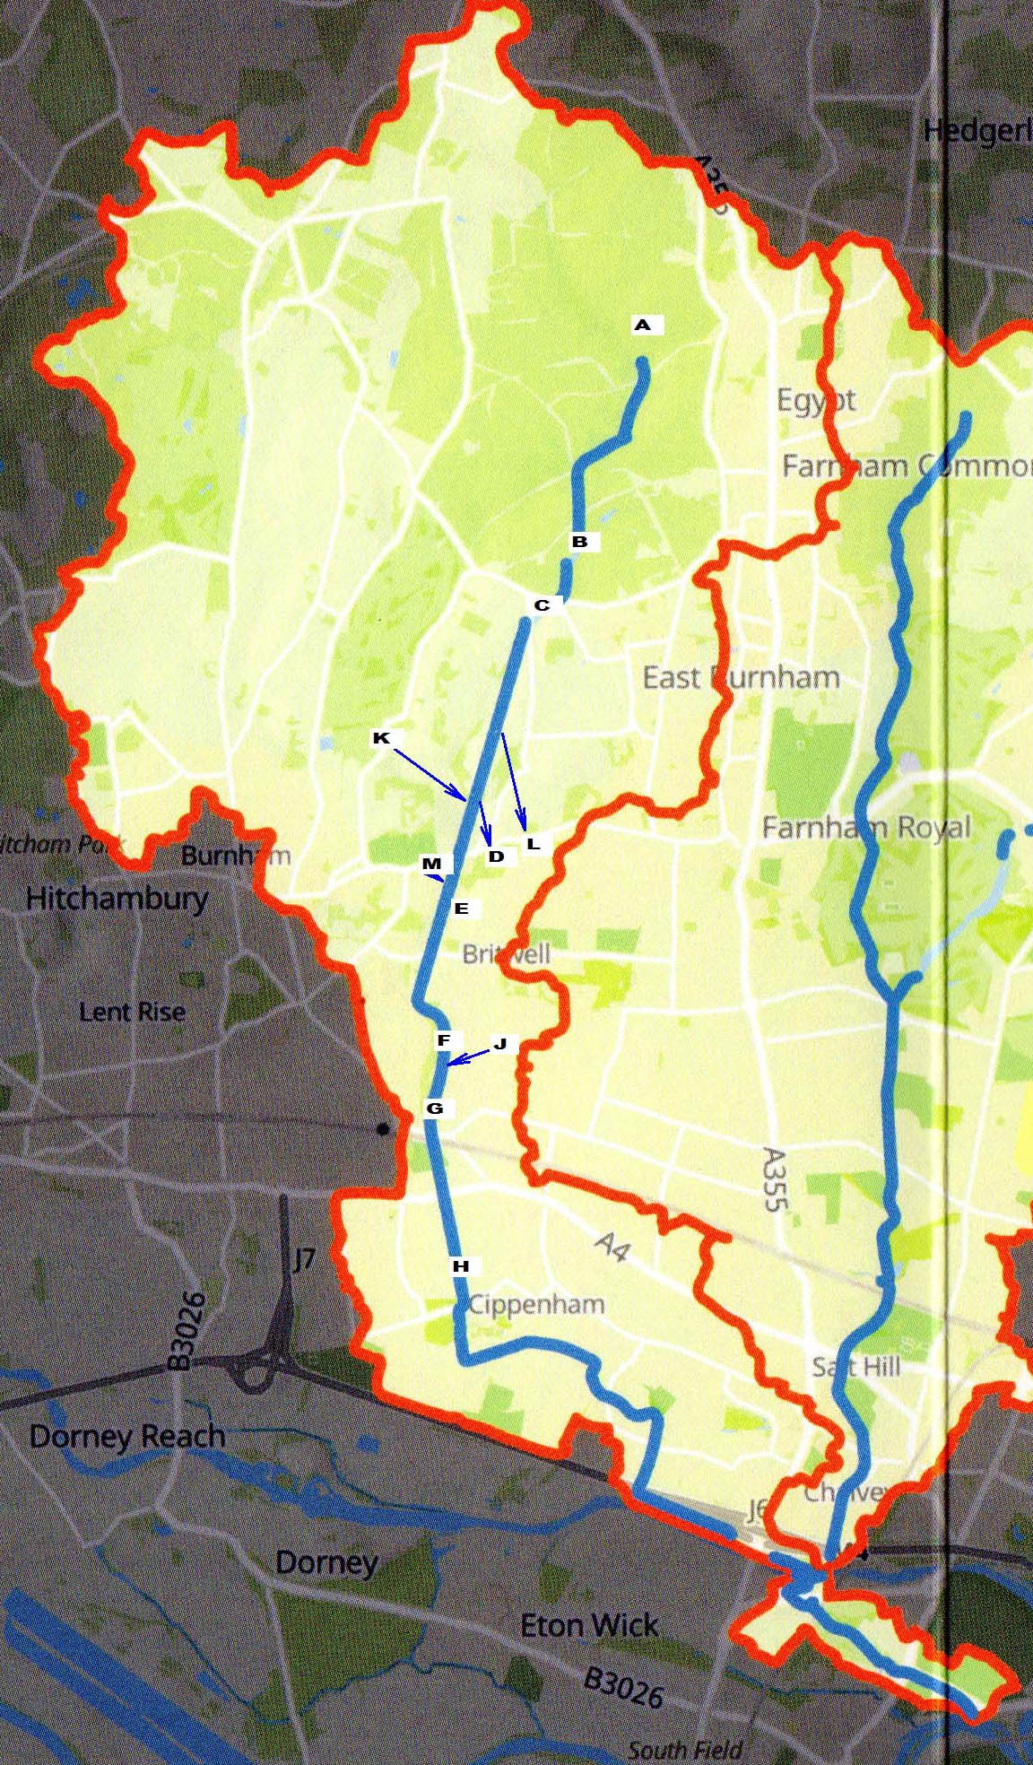

PROJECT SPONGE MAP 2024

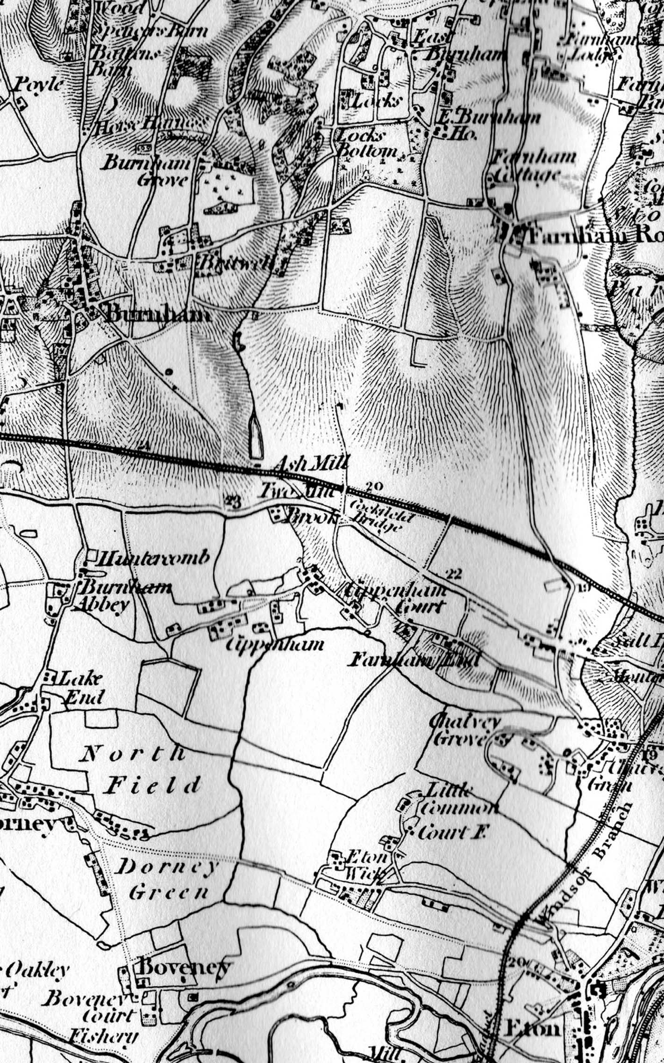

OS MAP OF 1891
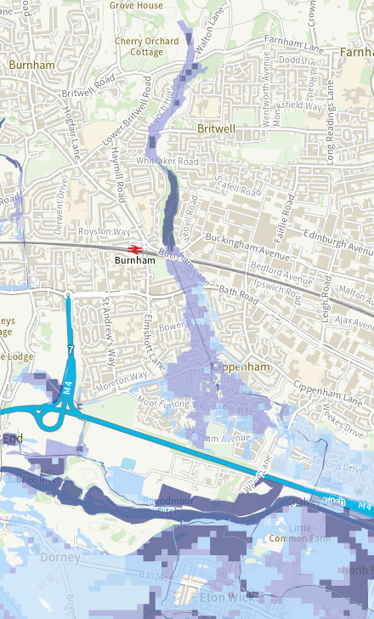

ENVIRONMENT AGENCY FLOOD MAP 2024

